Frederick Costello
CSD-325
M8 Assignment
05/10/2026
Resources used: Oxylabs, Microsoft Word, Copilot, Google

Program results
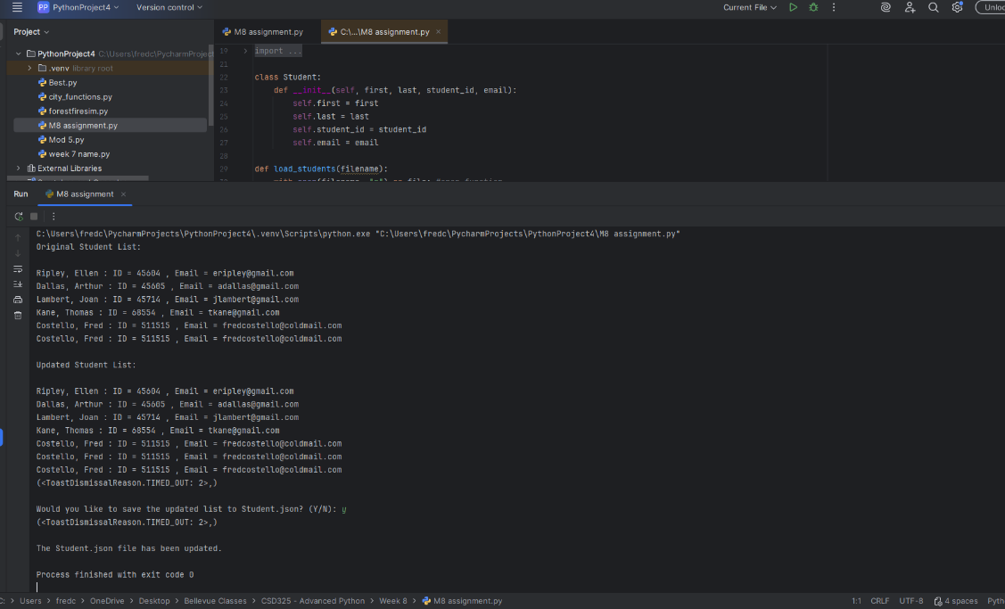

Update request
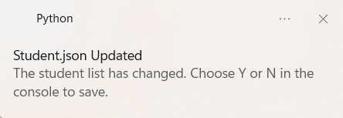

JSON file
